Unity description

By Jenna Kramer

45972168

Within my Unity game project, I have created an obstacle course in which will be played using the First person controller character. The outdoor section was built utilising the Terrain editor, using textures, 3D objects, hills, trees, and water. The house includes an outdoor section leading into a double roomed house, with a fire particle system and explosion and a TV made using an emissive material on the wall. This obstacle course starts at the top left hand side of the terrain. The player continues straight and jumps over the 3D objects- the stepping stones, turns left over the hills, over the pebbles and enemies in the water, and then go up the stairs into the house. After navigating through the house, passing the fire and the TV, you exit on the left and then jump over the wooden blocks and then finish on the other side at the end of the obstacle course. In my Game design document, I said that part of the obstacle would be collecting coins and flags, but I realised that it wouldn’t work as they are not in 3D. I modified some of these changes by adding more water and a walkthrough through the house.

The elements used in my 3D unity game:

* **House (25% for outdoors, 25% for indoors)**
* **Appropriate textures on the indoor section (5%)**
* o *With normal maps (add 5%)*
* **A simple single-state animation (5%)**
* **Direct light sources beyond the default Directional Light (5%)**
* o *Use of reflection-probes and reflective surfaces (add 5%)*
* o *Use of emissive materials (add 5%)*
* **Particle effects (10%)**
* **Objects controlled by physics (5%)**

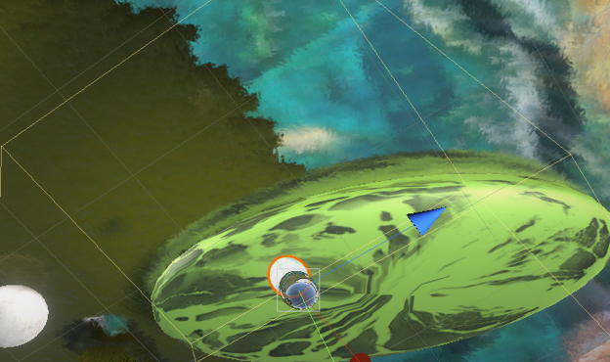

Adding a reflective probe and reflective surface

Adding directional lighting

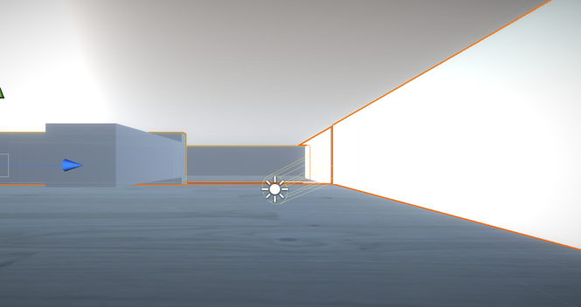

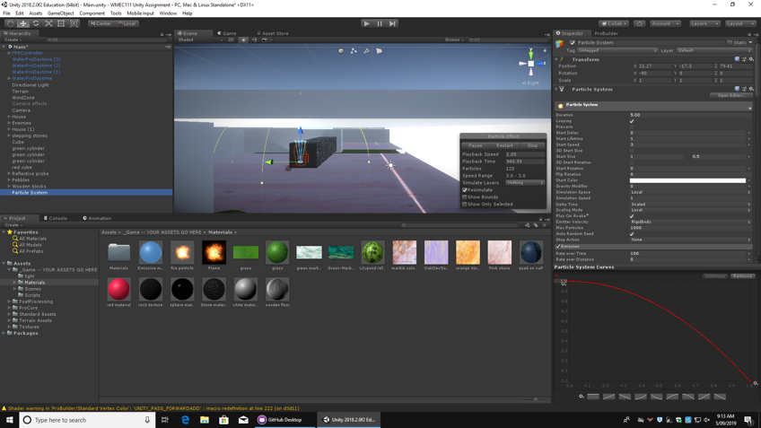 Adding a particle system